Module 4:
Online Shopping Cart
Jeremy Matthews
Colorado State University Global
CSC500– Principles of Programming
Dr. Douglas Mujeye
Due Date: 03/08/26

Online Shopping Cart
Psuedocode
CLASS ItemToPurchase
CONSTRUCTOR
SET item_name = "none"
SET item_price = 0.0
SET item_quantity = 0

METHOD print_item_cost
SET total = item_price * item_quantity
DISPLAY item_name, item_quantity, "@", item_price, "=", total

MAIN PROGRAM

// Item 1
DISPLAY "Item 1"
CREATE item1 as new ItemToPurchase

REPEAT
PROMPT user for item name
IF item name is empty THEN
DISPLAY "Item name cannot be empty."
UNTIL item name is not empty

REPEAT
TRY
PROMPT user for item price as float
IF item price < 0 THEN
DISPLAY "Price cannot be negative."
CATCH invalid input
DISPLAY "Please enter a valid number for the price."
UNTIL valid non-negative price is entered

REPEAT
TRY
PROMPT user for item quantity as integer
IF item quantity < 0 THEN
DISPLAY "Quantity cannot be negative."
CATCH invalid input
DISPLAY "Please enter a valid integer for the quantity."
UNTIL valid non-negative quantity is entered

// Item 2
DISPLAY "Item 2"
CREATE item2 as new ItemToPurchase

REPEAT
PROMPT user for item name
IF item name is empty THEN
DISPLAY "Item name cannot be empty."
UNTIL item name is not empty

REPEAT
TRY
PROMPT user for item price as float
IF item price < 0 THEN
DISPLAY "Price cannot be negative."
CATCH invalid input
DISPLAY "Please enter a valid number for the price."
UNTIL valid non-negative price is entered

REPEAT
TRY
PROMPT user for item quantity as integer
IF item quantity < 0 THEN
DISPLAY "Quantity cannot be negative."
CATCH invalid input
DISPLAY "Please enter a valid integer for the quantity."
UNTIL valid non-negative quantity is entered

// Calculate and display total
SET total_cost = (item1 price * item1 quantity) + (item2 price * item2 quantity)

DISPLAY "TOTAL COST"
CALL item1.print_item_cost()
CALL item2.print_item_cost()
DISPLAY "Total:", total_cost

END MAIN
Source Code
class ItemToPurchase:
def __init__(self):
self.item_name = "none"
self.item_price = 0.0
self.item_quantity = 0

def print_item_cost(self):
total = self.item_price * self.item_quantity
print(f"{self.item_name} {self.item_quantity} @ ${self.item_price:.2f} = ${total:.2f}")

if __name__ == "__main__":
# Item 1
print("Item 1")
item1 = ItemToPurchase()
while True:
item1.item_name = input("Enter the item name:\n").strip()
if item1.item_name:
break
print("Item name cannot be empty.")
while True:
try:
item1.item_price = float(input("Enter the item price:\n"))
if item1.item_price < 0:
print("Price cannot be negative.")
continue
break
except ValueError:
print("Please enter a valid number for the price.")
while True:
try:
item1.item_quantity = int(input("Enter the item quantity:\n"))
if item1.item_quantity < 0:
print("Quantity cannot be negative.")
continue
break
except ValueError:
print("Please enter a valid integer for the quantity.")

print()

# Item 2
print("Item 2")
item2 = ItemToPurchase()
while True:
item2.item_name = input("Enter the item name:\n").strip()
if item2.item_name:
break
print("Item name cannot be empty.")
while True:
try:
item2.item_price = float(input("Enter the item price:\n"))
if item2.item_price < 0:
print("Price cannot be negative.")
continue
break
except ValueError:
print("Please enter a valid number for the price.")
while True:
try:
item2.item_quantity = int(input("Enter the item quantity:\n"))
if item2.item_quantity < 0:
print("Quantity cannot be negative.")
continue
break
except ValueError:
print("Please enter a valid integer for the quantity.")

print()

# Output total cost
total_cost = (item1.item_price * item1.item_quantity) + (item2.item_price * item2.item_quantity)

print("TOTAL COST")
item1.print_item_cost()
item2.print_item_cost()
print(f"\nTotal: ${total_cost:.2f}")

Screenshots
Application Executing Program
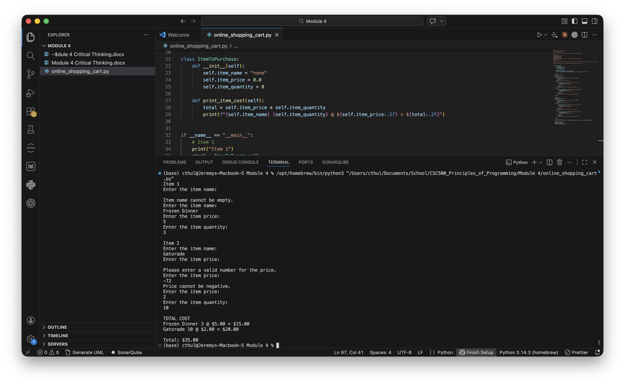

Results
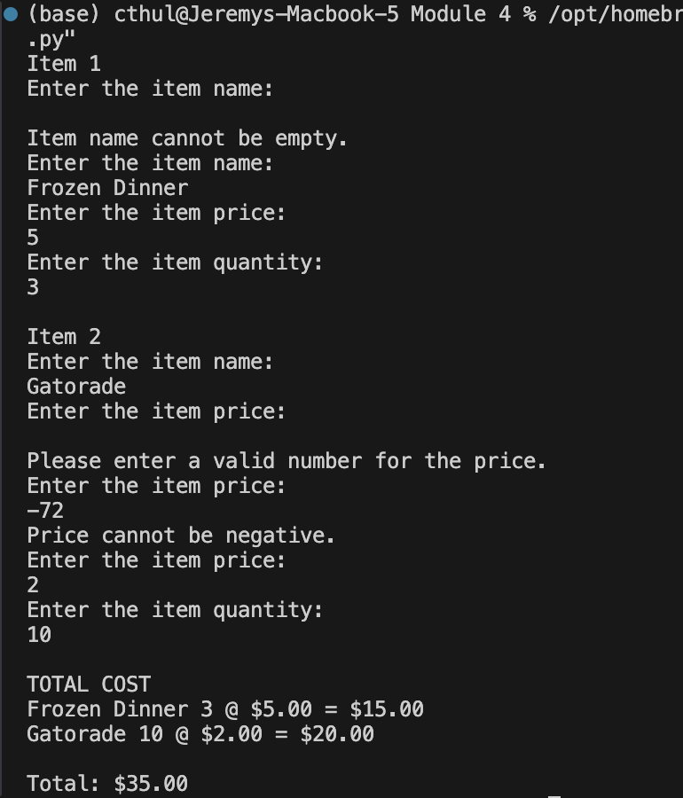

Github Repository
https://github.com/m9dful1/CSC500_Principles_of_Programming/tree/main/Module%204

